A Color Variant in Yellow Trout Lily (Erythronium americanum)
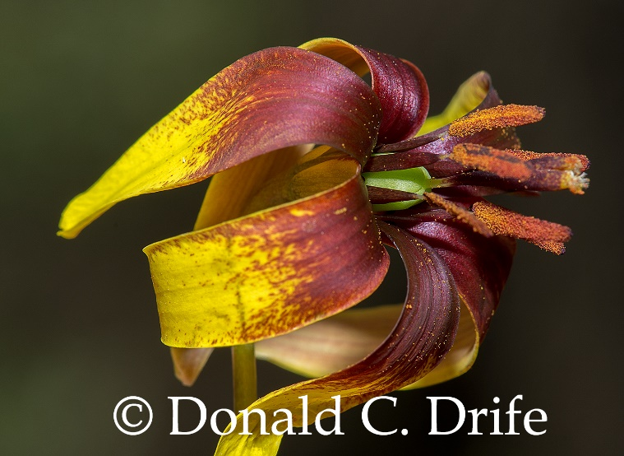
In the spring of 2019, Mary Fredricks showed Don Drife a small patch of Yellow Trout Lily, in Cummingston, with the base of the tepals reddish-brown on the inner surface. The two-toned plants were striking. Trout Lilies can reproduce vegetatively through stolons. This patch might be a single clone spreading via stolons.
Don checked the Michigan Flora Website and it said, “Rarely the perianth is reddish brown basally. Flora of North America says “Flowers: tepals yellow, sometimes tinged light to dark purple-red abaxially, sometimes with reddish dots adaxially,” So this variation is known. Don just never saw it before. Lyman Smith named this color form as forma castaneum. It will be interesting to hear of other colonies. Don thanks Mushroom Mary for pointing this patch out. More information can be found at http://www.michigannatureguy.com/blog/2019/05/02/a-color-variant-erythronium-americanum/.

